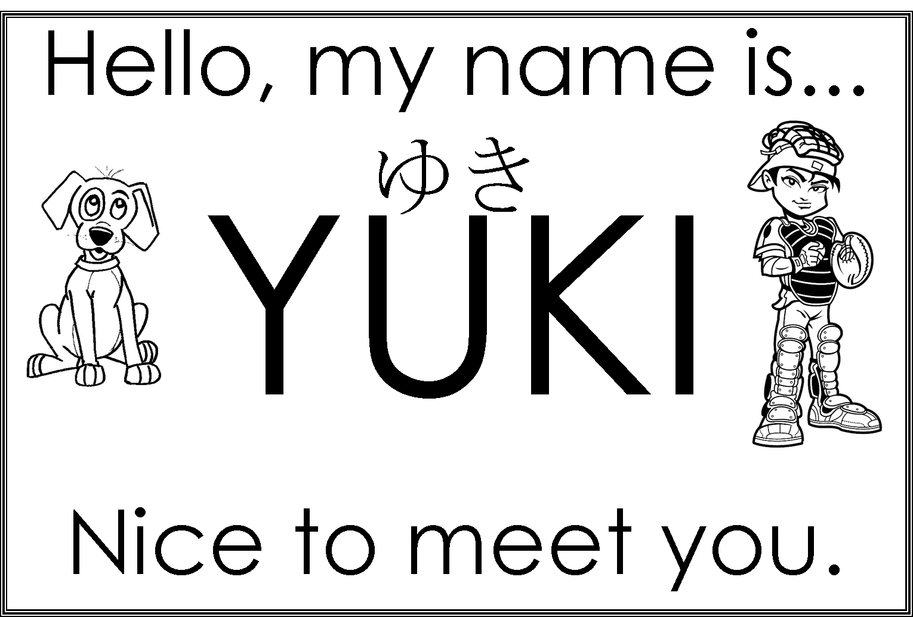

Hello, my name is...

Nice to meet you.

Hello, my name is...

Nice to meet you.

Hello, my name is...

Nice to meet you.

Hello, my name is...

Nice to meet you.

Hello, my name is...

Nice to meet you.

Hello, my name is...

Nice to meet you.