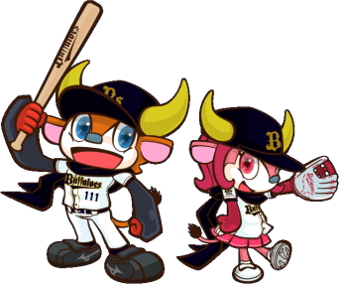

Hotto Motto Stadium



Tetsujin



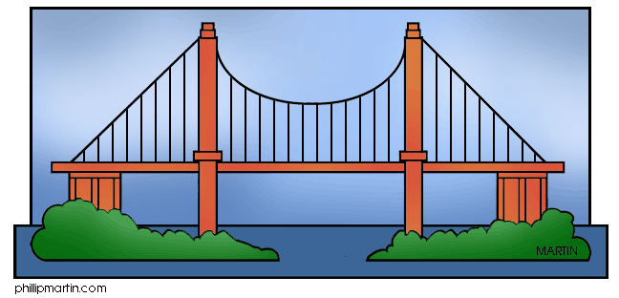Akashi Bridge

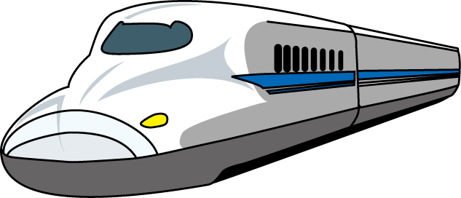

the Shinkansen

C:\Users\j803kyozai\AppData\Local\Microsoft\Windows\Temporary Internet Files\Content.IE5\77XUV274\MC900412042[1].wmf

the park

Gakuentoshi

Sogoundokoen

Shin-nagata

Hyogo

Sumaura Koen

Sannnomiya

Shin-Kobe

Maiko



the **JR** Line

the **Yamate** Line

the **Sanyo** Line

**START**

Kobe

A: Excuse me. How can I get to __________________?

B: Take the ___________ Line.

Get off at ________________ Station.

A: ________________ Station. I see. Thank you.

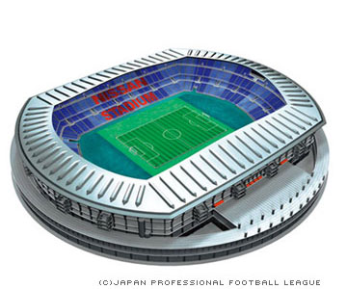

Home’s Stadium



Graham’s House

**Let’s go to:**

and



Hotto Motto Stadium



Graham’s House



Home’s Stadium



Tetsujin



C:\Users\j803kyozai\AppData\Local\Microsoft\Windows\Temporary Internet Files\Content.IE5\77XUV274\MC900412042[1].wmf

the park

Gakuentoshi

Sogoundokoen

Shin-nagata

Hyogo

Sumaura Koen

Sannnomiya

Shin-Kobe

Maiko



the **JR** Line

the **Yamate** Line

the **Sanyo** Line

**START**

Kobe

A: Excuse me. How can I get to __________________?

B: Take the ___________ Line.

Get off at ________________ Station.

A: ________________ Station. I see. Thank you.



the Shinkansen

Akashi Bridge

**Let’s go to:**

and



Graham’s House



Home’s Stadium



Tetsujin

Akashi Bridge



the Shinkansen

C:\Users\j803kyozai\AppData\Local\Microsoft\Windows\Temporary Internet Files\Content.IE5\77XUV274\MC900412042[1].wmf

the park

Gakuentoshi

Sogoundokoen

Shin-nagata

Hyogo

Sumaura Koen

Sannnomiya

Shin-Kobe

Maiko



the **JR** Line

the **Yamate** Line

the **Sanyo** Line

**START**

Kobe

A: Excuse me. How can I get to __________________?

B: Take the ___________ Line.

Get off at ________________ Station.

A: ________________ Station. I see. Thank you.





Hotto Motto Stadium

**Let’s go to:**

and



Hotto Motto Stadium



Graham’s House



Home’s Stadium



Akashi Bridge



the Shinkansen

Gakuentoshi

Sogoundokoen

Shin-nagata

Hyogo

Sumaura Koen

Sannnomiya

Shin-Kobe

Maiko



the **JR** Line

the **Yamate** Line

the **Sanyo** Line

**START**

Kobe

A: Excuse me. How can I get to __________________?

B: Take the ___________ Line.

Get off at ________________ Station.

A: ________________ Station. I see. Thank you.

C:\Users\j803kyozai\AppData\Local\Microsoft\Windows\Temporary Internet Files\Content.IE5\77XUV274\MC900412042[1].wmf

the park



Tetsujin

**Let’s go to:**

and

Class:______ Number:______ Name:________________________________

**START**



Hotto Motto Stadium



Graham’s House



Tetsujin

Akashi Bridge



the Shinkansen

C:\Users\j803kyozai\AppData\Local\Microsoft\Windows\Temporary Internet Files\Content.IE5\77XUV274\MC900412042[1].wmf

the park

Gakuentoshi

Sogoundokoen

Shin-nagata

Sumaura Koen

Sannnomiya

Shin-Kobe

Maiko

Itayado



the **JR** Line

the **Yamate** Line

the **Sanyo** Line



Home’s Stadium



Hyogo

Kobe

Change trains to the B Line.

B線に乗り換えてください。

C Station is the third stop.

C駅は3駅めです。

Take the B Line at D Station.

D駅でB線に乗ってください。

IDEA BOX

Let’s write:

______________________________________________________________________

______________________________________________________________________

______________________________________________________________________

______________________________________________________________________

______________________________________________________________________

______________________________________________________________________

______________________________________________________________________

______________________________________________________________________