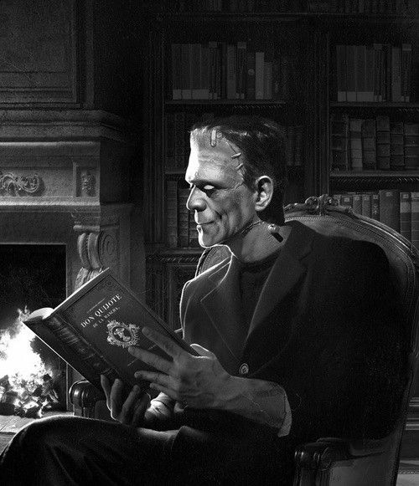
Franken-Story!
Students race to write a story about a
given topic on the board. E.g., zombies,
camping at night, favorite candies

Groups of 5-8

Procedure
- Students line up in their group facing the board
- Each student writes 3 words, then goes to the back of the line

Points
- 1 point is awarded for every:
  - Word
  - Exceptional or humorous phrase
- 1 point is subtracted for each:
  - Spelling mistake
  - Grammar mistake
  - Nonsense phrase

Students will randomly draw chopsticks, 1-3 of which are colored. The students with colored chopsticks can opt to:
- Read the story (1 point)
- Read with:
  - Acting (with gestures and emotion) (3-5 points)
  - Singing with emotion (3-5 points)

Level UP! 2 students can create a combined story topic by each writing a random topic on the board. Teams can get 3 points for each topic they use in an understandable way.
Franken-Story!
Students race to write a story about a
given topic on the board. E.g., zombies,
camping at night, favorite candies

Groups of 5-8

Procedure
- Students line up in their group facing the board
- Each student writes 3 words, then goes to the back of the line

Points
- 1 point is awarded for every:
  - Word
  - Exceptional or humorous phrase
- 1 point is subtracted for each:
  - Spelling mistake
  - Grammar mistake
  - Nonsense phrase

Students will randomly draw chopsticks, 1-3 of which are colored. The students with colored chopsticks can opt to:
- Read the story (1 point)
- Read with:
  - Acting (with gestures and emotion) (3-5 points)
  - Singing with emotion (3-5 points)

Level UP! 2 students can create a combined story topic by each writing a random topic on the board. Teams can get 3 points for each topic they use in an understandable way.

