North Line

**Main Station**

(You are here)

East Line

West Line

South Line

North Line

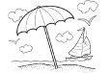

the ocean

**Main Station**

(You are here)

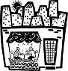

the cafe

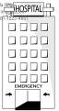

the hospital

East Line

West Line

South Line

ｎ

North Line

**Main Station**

(You are here)

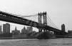

the bridge



Koyo Junior High School



the hospital

The Hospital

East Line

West Line

South Line

North Line

**Main Station**

(You are here)

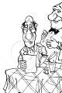

the restaurant

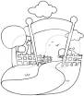

the zoo



the hospital

East Line

West Line

South Line

North Line

**Main Station**

(You are here)



the bus stop



the hospital

The Hospital

East Line

West Line

South Line

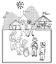

the amusement park

The amusement park

North Line



the ocean

**Main Station**

(You are here)



the hospital

The Hospital

East Line

West Line

South Line

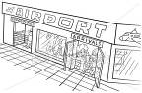

the airport

North Line

**Main Station**

(You are here)



the bridge



the cafe



the hospital

The Hospital

East Line

West Line

South Line

North Line

**Main Station**

(You are here)



the hospital

The Hospital

East Line

West Line

South Line



the bus stop



the amusement park

The amusement park

North Line



the ocean

**Main Station**

(You are here)



the bridge



the hospital

The Hospital

East Line

West Line

South Line

North Line

**Main Station**

(You are here)



the zoo



the hospital

The Hospital

East Line

West Line

South Line



the amusement park

The amusement park

North Line

**Main Station**

(You are here)



Koyo Junior High School



the cafe



the hospital

The Hospital

East Line

West Line

South Line

North Line

**Main Station**

(You are here)



the bus stop



the hospital

The Hospital

East Line

West Line

South Line



the airport

North Line



the ocean

**Main Station**

(You are here)



the restaurant



the zoo



the bus stop



the bridge



Koyo Junior High School



the cafe



the hospital

The Hospital

East Line

West Line

South Line



the amusement park

The amusement park



the airport