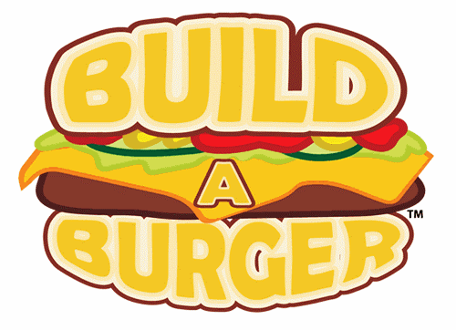
Aさん：Which ______ do you want?
Bさん：I want beef, please.
Meat
- beef | - chicken | - tofu
Toppings
- cheese | - lettuce | - tomato | - pickles | - pineapple
- onions | - bacon | - egg | - avocado

Sauce
- mayo | - mustard | - ketchup | - tabasco

Side
- french fries | - onion rings | - salad

Drink
- water | - tea | - coffee | - orange juice | - cola | - melon soda

