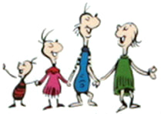

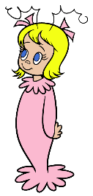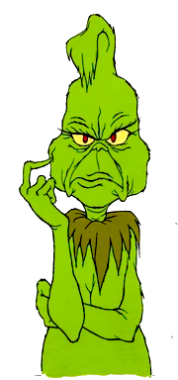Characters:

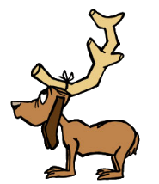

|  |  |
| --- | --- |
| The Whos in Whoville | The Grinch |
| Max the Dog | Cindy Lou Who |

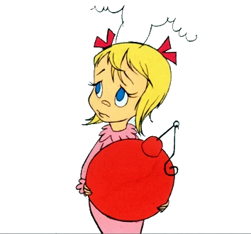Word Box

1. The Whos in Whoville _____________ Christmas a lot.
2. The Grinch’s heart is too big. TRUE / FALSE
3. The Grinch hates singing and __________________.
4. On Christmas, the Whos in Whoville _________________.
5. The song says “You’re a ________________ one, Mr. Grinch.”
6. The Grinch wears a ______________________ coat and hat.
7. Max the dog wears a _________________ horn.
8. The Whos in Whoville are sleeping when the Grinch comes. TRUE / FALSE
9. The Grinch takes the stockings first. TRUE / FALSE
10. Cindy Lou Who is _________________ years old.
11. The Grinch takes all the food. TRUE / FALSE
12. Last, the Grinch takes the big Christmas ______________.
13. The Grinch stops Christmas. TRUE / FALSE
14. The Grinch’s ________________ gets bigger.
15. The Grinch gives food to Max the dog. TRUE / FALSE

|  |  |  |
| --- | --- | --- |
| 1. tree | 4. noise | 7. reindeer |
| 1. two | 5. like | 8. mean |
| 1. heart | 6. sing | 9. Santa Claus |

